**Limitations of Hierarchical Clustering**

1. Hierarchical clustering doesn’t have math objective function that we are directly solving

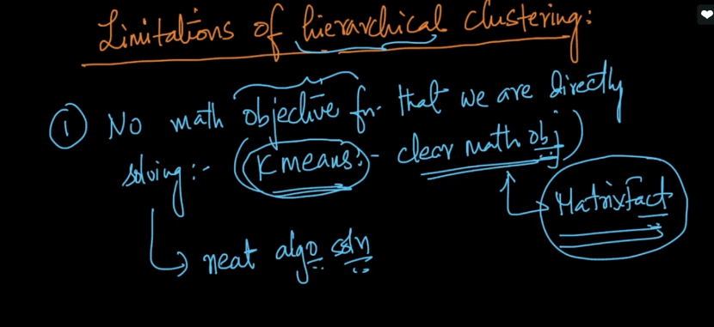

1. Proximity problems have their own limitaions like min, max and group average also have their own problems because it is a combination of min and max.
2. Most important limitation is space and time complexity therefore we can’t use it when n is large

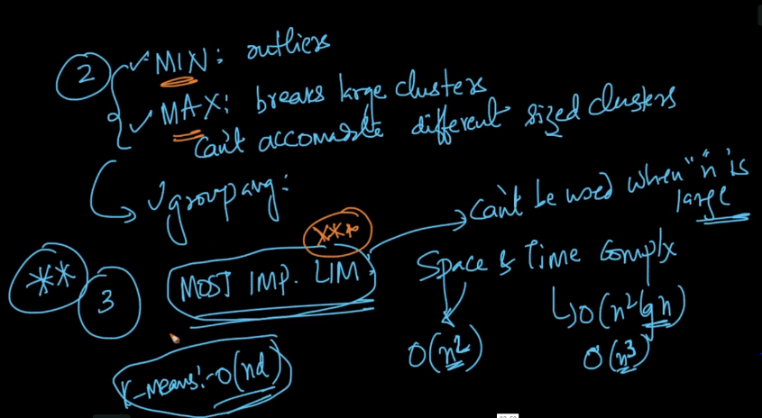

Comments :

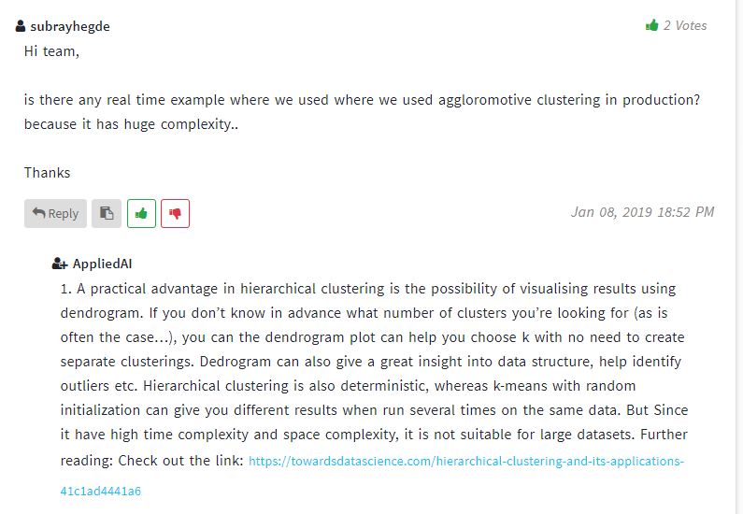

Links :

<https://towardsdatascience.com/hierarchical-clustering-and-its-applications-41c1ad4441a6>